**HUGE 2017**

**Songs from the Musicals**

**PROGRAMME**

**Saturday 17th June**

**Sunday 18th June**

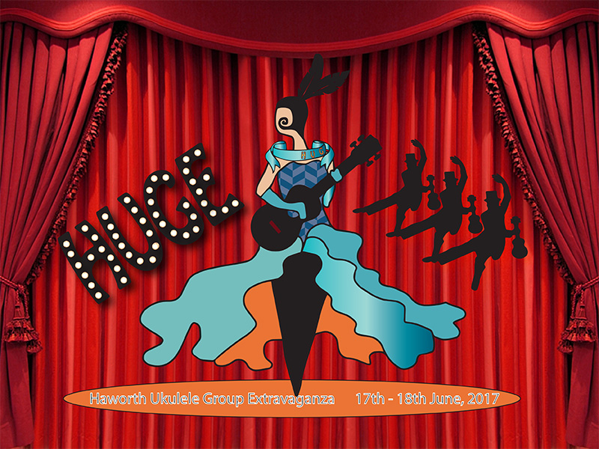

**Saturday 17th June – £6 including 2017 HUGE Songbook**

**11.00 Haworth Old School Rooms - doors open**

**11.30 – 12.45 Uke session at the Black Bull (top of Main Street, Haworth)**

**1.00 p.m. Welcome to HUGE - Songs from the Musicals!**

1.10 Haworth Ukulele Group

1.30  Bradford Ukes

1.50 Saltaire Strummers

2.10  Baildon Ukulele Club

2.30  3 Chord Max

2.50 RAFFLE DRAW!!

3.00 Lemon Tree Lunchalele

3.20  Bolton Ukulele Group

3.40 Luxulele

4.00  Ilkley Ukulele Dance Band

4.20 Skipton Ukulele Club

4.40 HUGE Songbook Finale!!

Be ready! In between sets we’ll be strumming songs from the HUGE 2017 songbook

5.30 p.m. School Rooms Close – time to eat before the evening concert at

Cobbles and Clay Café.

**7.30 – 10.30 p.m. – Charity Event**

Cobbles and Clay Café, Main St, Haworth Tickets £5

Great entertainment from No Fluke and plenty of chances to join in and strum or sing along.

** Sunday 18th June - Ukulele Steam Special**

**11.51 a.m. from Haworth Station - on the Keighley and Worth Valley Railway**

Toot, Toot! All aboard the original KWVR Ukulele Stream Train Special! Bring your HUGE 2017 songbooks and join us in our private carriage for a round trip on the KWVR arriving back at Haworth at approximately 13.20 Tickets must be bought before boarding the train so please allow plenty of time. If the weather is kind there will be an informal jam session after the train in the garden at a pub.

Don’t forget to pick up your voucher at HUGE to get a reduced fare of £9.20 for the HUGE 2017 Steam Train Special.

**SATURDAY EVENING CHARITY EVENT £5.00**

 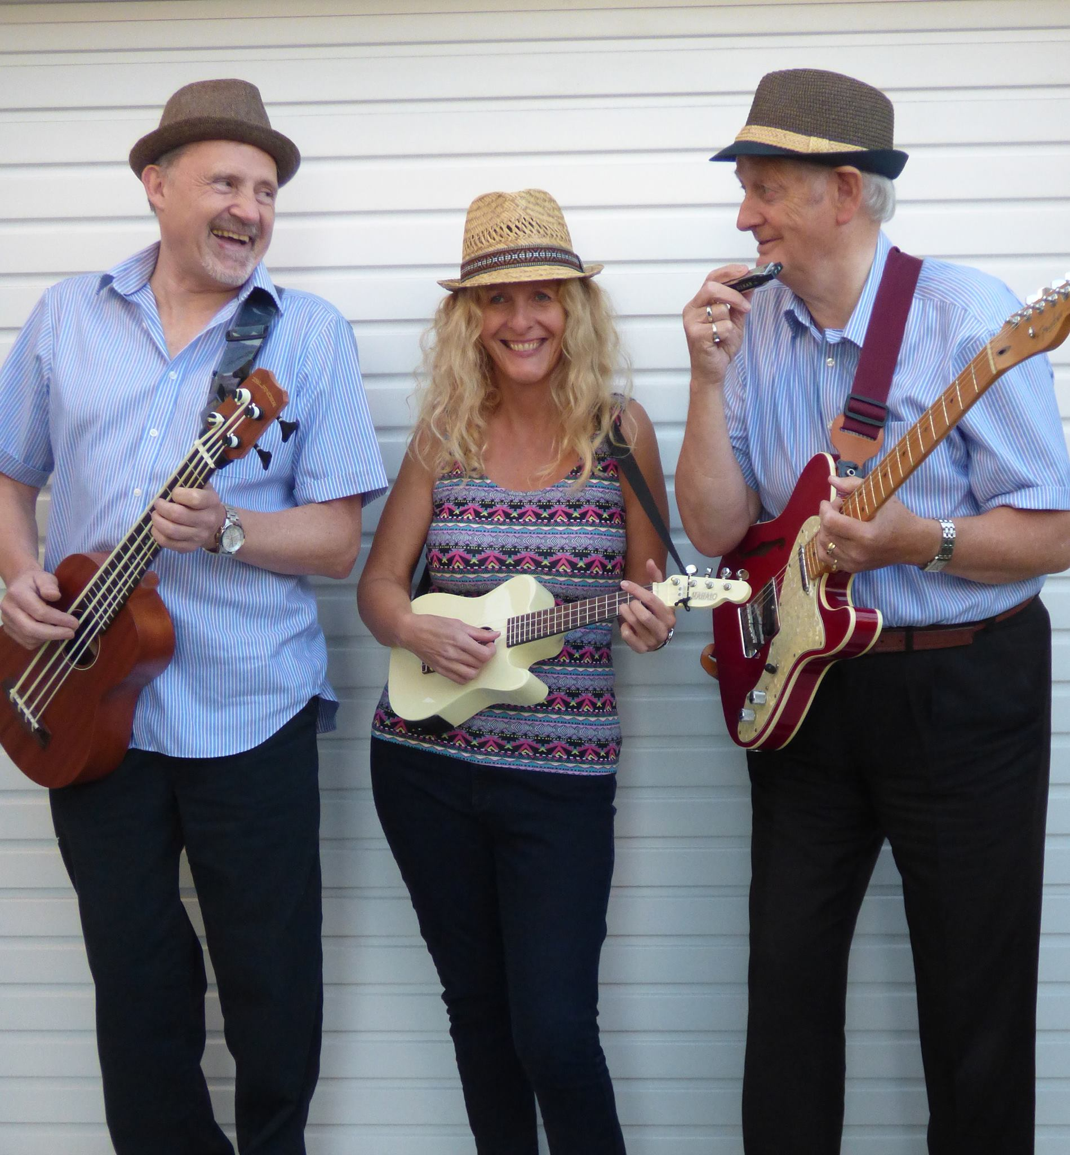

Cobbles and Clay Café 7.30 – 10.30 p.m.

Come and have musical fun at our HUGE evening event at Cobbles and Clay Café, Main Street, Haworth. The very talented and entertaining No Fluke will be playing songs we all know and inviting us to join in.

All proceeds to our chosen charities.

Tickets available from HUG members, HUGE merchandise stall and Cobbles and Clay Café.

HUGE is a non-profit making event run by volunteers from Haworth Ukulele Group. Our aim is to provide an informal event where ukulele players at all levels can get together to have fun playing uke, sharing songs and learning from each other while at the same time raising funds for local charities. Our mission is we’ll all be strumming ukes about every 20 minutes!

We cover all our own costs so we are asking everyone to make a contribution of £6 to support the event. This £6 entry for the afternoon in the Old School Rooms includes the 2017 Songbook. The whole event – afternoon session, evening concert with No Fluke and the Ukulele Steam Train Special - costs a total of £20.20 per person but we’ve broken down these costs as not everyone can be at everything. We think that’s a great deal for a fantastic weekend of ukulele fun. We hope you agree.

Please help us to make it a HUGE success and support our chosen charities:

Sue Ryder Manorlands Hospice

Bradford and Airedale Mental Health Advocacy Group

HUGE RAFFLE AND TOMBOLA!

HUGE 2016 AND 2017 SONGBOOKS AND HUGE 2017 T-SHIRTS ON SALE

Licensed bar selling tea/coffee/soft drinks/wine and HUGE ALE!

(Please note – only alcohol purchased at the event may be consumed on the premises)

HUGE 2017 – SONGS FROM THE MUSICALS!

The theme of HUGE 2017 is Songs from the Musicals. Each group performing has been asked to include a song or two from a musical in their set and there are songs from the musicals included in this year’s HUGE Songbook.

 HUGE is proud to be part of Haworth Festival**,** an annual community based arts and music festival organised by volunteers.