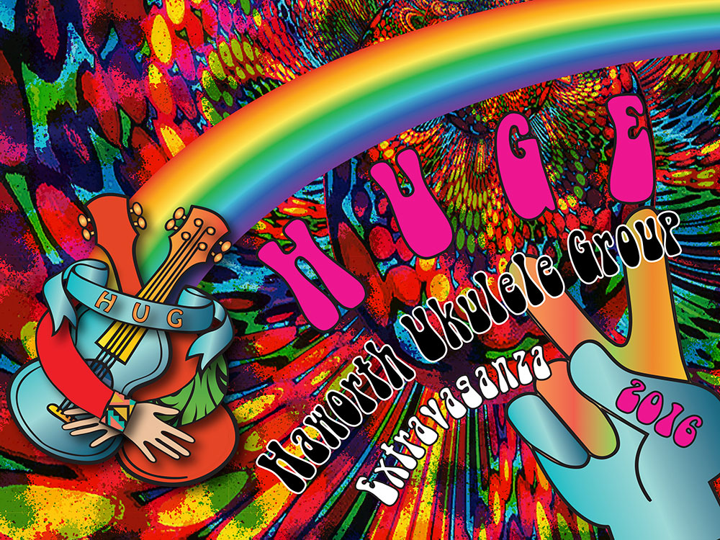
HUGE 2016
PROGRAMME
Saturday 25th
Old School Rooms, Haworth
Sunday 26th June
KWVR

Saturday 25th June – Old School Rooms, Haworth

11.30 a.m Doors open
12.00 Workshops: various locations – see next page for details
2.00 p.m. Welcome to HUGE from Haworth Ukulele Group!

Blues Jam Session song led by Keef Jackman

2.30 Saltaire Strummers
2.50 Baildon Ukulele Club
3.10 The Late Comers
3.30 Skipton Ukulele Club
3.50 Ilkley Ukulele Dance Band
4.10 Keighley Ukulele Orchestra
4.30 3 Chord Max
4.50 The Bradford Ukes

Prize Draw and Raffle

5.10 – 6.00 p.m. Mass ukulele strum from the HUGE 2016 Songbook

7.00 – 10.30 p.m. FAB AND GROOVY 60s PARTY – featuring live music from:

Keef Jackman
Reuben and Ruth
No Fluke

Plus ukulele strumming 60s sounds, plus spinning your fave discs and dancing the night away 60s style.

Sunday 26th June - Ukulele Steam Special
11.06 a.m. from Haworth Station - Ukulele Steam Train Special on the Keighley and Worth Valley Railway
Join us in our private carriage for a round trip on the KWVR arriving back at Haworth at approximately 12.35. Tickets must be bought before boarding the train so please allow plenty of time. If the weather is kind there will be an informal jam session after the train in the garden at Haworth Old Hall pub.

HUGE 2016 WORKSHOPS
12.00 – 1.30pm.

The beginners and strumming workshops cost £3 per person with maximum numbers of 15 per workshop. There is no advance booking for workshops. Under 14s must be accompanied by an adult.

Learn to Play Ukulele – Beginners Workshop:
Venue: The Old School Rooms
This workshop will introduce you to the ukulele and you’ll learn a few basic chords that will get you playing at least one of the songs from our 2016 songbook. Bring your own ukulele or if you haven’t played before and just want to have a go there will be some ukes available to borrow for the workshop. £3 per person

Strummers Guide – Basic Strumming Techniques Venue: The Old School Rooms, Haworth
For relatively new uke players who want to get to grips with different strumming patterns and techniques. This workshop is always hugely successful. £3 per person

What a Performance!
- blues session/workshop
Venue: The Black Bull, Main Street, Haworth
Ukulele Blues man Keef Jackman will introduce you to some blues ukulele techniques and work on a song with you so that you are ready to perform with Keef on stage in the afternoon. Suitable for more confident uke players who want to stretch themselves a bit.
Donations to charity please.
HUGE 2016 - ENTRY £5
Including 2016 songbook, afternoon of entertainment and evening 60s party.

HUGE is a non-profit making event run by volunteers from Haworth Ukulele Group. Our aim is to provide an informal event where ukulele players at all levels can get together to have fun playing uke, sharing songs and learning from each other while at the same time raising funds for local charities.

This year, for the first time, we have to cover all our own costs for venue etc. That’s why this year we are asking everyone who takes part to make a contribution of £5 to support the event.

We hope you’ll help us to make it a huge success and support local charities.

